# Advance Excel Assignment 6

# What are the various elements of the Excel interface? Describe how they're used.

Excel has two main UI components:

1. The Interface Components
2. the Workbook Components.

**Interface Components**

The interface components of Excel include the Quick Access Toolbar, Ribbon, Name Box, Formula Quick Menu, Formula Bar, Status Bar, Worksheet View Options, Zoom Slider Control, and the Zoom Percentage Indicator.

**Quick Access Toolbar:**

 The Quick Access Toolbar is found on the top-left of the Excel window which contains the commonly used commands in Excel. This toolbar can be customized and lets you choose which commands you want access easily. By default, this contains the save, undo, and redo commands.

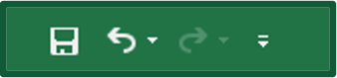

**Ribbon:**

The Ribbon interface contains the commands that are available for use in Excel. This has multiple tabs including the File, Home, Insert, Page Layout, Formulas, Data, Review, View, Add-ins, and Help tabs. There are tabs that will appear when necessary; for example, the Format tab appears when you click an inserted shape.

The tabs are then subdivided in groups based on the usage of the commands. For example, in the home tab, the commands are grouped in Clipboard, Font, Alignment, Number, Styles, Cells, and Editing

**Name Box**:

The Name Box is an input box which normally displays the name or location of the active cell on the worksheet. This is also used to directly create a named range. When you open a blank workbook, the selected cell is A1, by default.

**Formula Quick Menu**

The Formula Quick Menu beside the Name box is a shortcut when you want to insert a function. If you click the ***fx***option, the Insert Function will pop-up to let you choose which Excel function would you like to use.

**Formula Bar:**

The Formula Bar is found just beside the Formula Quick Menu. This allows you to enter or edit data, formula or a function that will appear in the selected cell whose name or location appears in the Name Box.



**Status Bar**:

The Status Bar in the bottom-left corner of the Excel window displays various information about the current mode of the workbook.



**Worksheet View Options:**

The Worksheet View Options lets you choose which of the 3 worksheet views you want (Normal, Page Layout, or Page Break Preview). By default, the worksheet view is set to Normal.

**Zoom Slider Control:**

 The Zoom Slider Control helps you zoom in and zoom out the worksheet.

**Zoom Percentage Indicator**

The Zoom Percentage Indicator displays the zoom percentage just beside the Zoom Slider Control. By default, it is set to 100%.

# Write down the various applications of Excel in the industry.

* Finance and Accounting
* Marketing and Product Management
* Human Resources Planning
* Data collection

# 3. On the ribbon, make a new tab. Add some different groups, insert commands in the groups and name them according to their commands added. Copy and paste the screenshot of the steps you followed.

**How to create a new tab for the ribbon**

To make your favorite commands easily accessible, you can add your own tab to the Excel ribbon. Here's how:

1. In the Customize the Ribbon window, under the list of tabs, click the **New Tab** button.

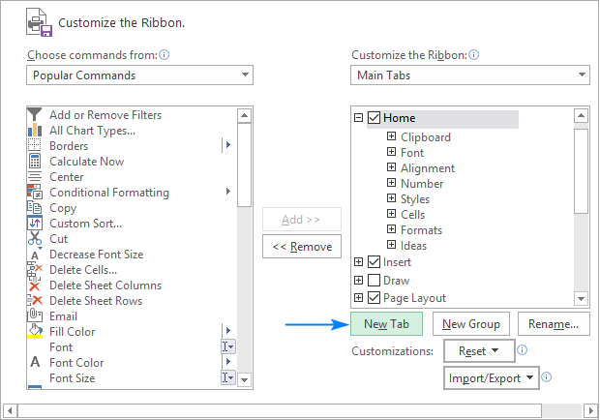

This adds a custom tab with a custom group because commands can only be added to custom groups.

1. Select the newly created tab, named New Tab (Custom), and click the **Rename…** button to give your tab an appropriate name. In the same manner, change the default name given by Excel to a custom group. For the detailed guidelines, please see [how to rename ribbon items](https://www.ablebits.com/office-addins-blog/customize-ribbon-excel/#rename-tabs-groups-command).
2. When done, click OK to save the changes.

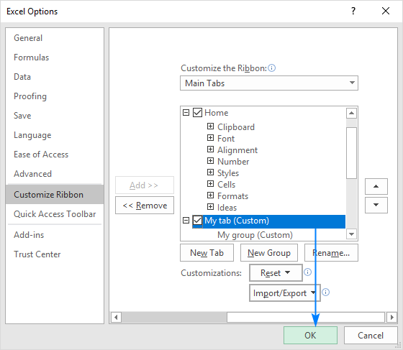

1. As shown in the screenshot below, our custom tab is added to the Excel ribbon at once, though the custom group is not displayed because it is empty. For the group to show up, it must have at least one command. We will [add commands to our custom tab](https://www.ablebits.com/office-addins-blog/customize-ribbon-excel/#add-command-to-ribbon) in a moment but, to be consistent, we will first look at how to create a custom group.

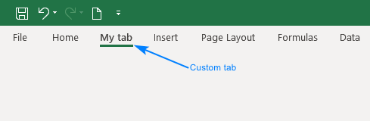

**Tips and notes:**

* By default, a custom tab is placed **after the currently selected tab** (after the Home tab in our case), but you are free to [move](https://www.ablebits.com/office-addins-blog/customize-ribbon-excel/#move-tabs-groups-command) it anywhere on the ribbon.
* Each tab and group that you create have the word Custom after their names, which is added automatically to distinguish between built-in and custom items. The word (Custom) only appears in the Customize Ribbon window, not on the ribbon.

**How to add a custom group to a ribbon tab**

To add a new group to either a default or custom tab, this is what you need to do:

1. In the right part of the Customize the Ribbon window, select the tab to which you'd like to add a new group.
2. Click the **New Group**button. This adds a custom group, named New Group (Custom), at the bottom of the list of groups, meaning the group displays on the far-right end of the tab. To create a new group in a specific location, select the group after which the new group is to appear.

In this example, we're going to add a custom group to the end of the home tab, so we select it, and click **New Group**:

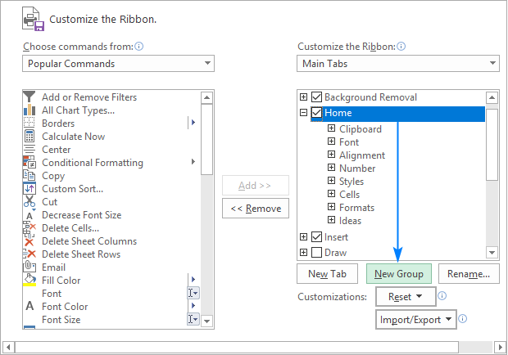

1. To rename your custom group, select it, click the **Rename…**button, type the desired name, and click OK.

Optionally, from the **Symbol** box, select the icon to be your custom group. This icon will appear on the ribbon when the Excel window is too narrow to show the commands, so only the group names and icons are displayed. Please see [how to rename items on the ribbon](https://www.ablebits.com/office-addins-blog/customize-ribbon-excel/#rename-tabs-groups-command) for full details.

1. Click OK to save and view your changes.

**Tip.** To save some room on the ribbon, you can [remove text](https://www.ablebits.com/office-addins-blog/customize-ribbon-excel/#hide-command-labels-show-only-icons) from the commands in your custom group and show only the icons.

**How to add a command button to Excel ribbon**

Commands can only be added to custom groups. So, before adding a command, be sure to [create a custom group](https://www.ablebits.com/office-addins-blog/customize-ribbon-excel/#add-your-own-ribbon-group) on an inbuilt or custom tab first, and then perform the below steps.

1. In the list under Customize the Ribbon, select the target custom group.
2. In the Choose commands from drop-down list on the left, select the list from which you want to add commands, for example, Popular Commands or Commands Not in the Ribbon.
3. In the list of commands on the left, click the command you want to add.
4. Click the **Add** button.
5. Click OK to save the changes.

As an example, we are adding add the Subscript and Superscript buttons to the custom tab that we created:

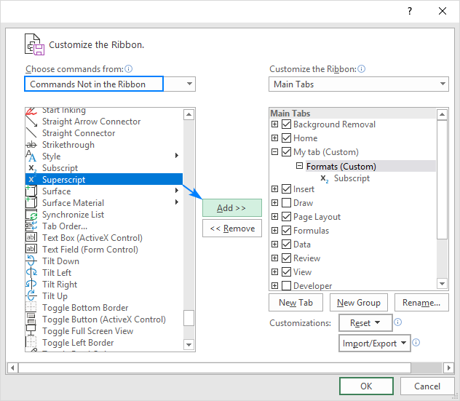

As the result, we now have a custom ribbon tab with two buttons:

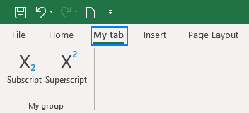

**Rename ribbon tabs, groups and commands**

In addition to giving your own names to custom tabs and groups that you create; Excel allows you to rename the built-in tabs and groups. However, you cannot change names of the inbuilt commands, only commands added to custom groups can be renamed.

To rename a tab, group or custom command, carry out these steps:

1. On the right side of the Customize the Ribbon window, click on the item you want to rename.
2. Click the **Rename** button below the list if tabs.
3. In the Display name box, type the name you want, and click OK.
4. Click OK to close the Excel Options window and view your changes.

For **groups** and **commands**, you can also select an icon from the Symbol box, like shown in the screenshot below:

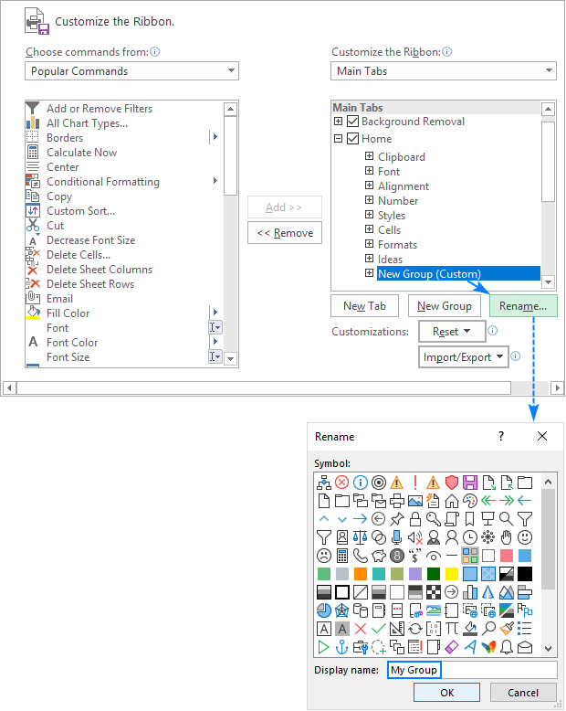

**Note.** You can change the name of any custom and build-in tab, except the File tab that cannot be renamed.

# 4.Make a list of different shortcut keys that are only connected to formatting with their functions.

* **Ctrl + B:**Bold highlighted selection.
* **Ctrl + I:**Italic highlighted selection.
* **Ctrl + K:**Insert link (Shortcut Keys and their Functions).
* **Ctrl + U:**Underline highlighted selection
* **Ctrl + L:**Aligns the line or selected text to the left of the screen.
* **Ctrl + E:**Aligns the line or selected text to the center of the screen.
* **Ctrl + R:**Aligns the line or selected text to the right of the screen.
* **Ctrl + M:**Indent the paragraph.
* **Ctrl + Shift + F:**Change the font
* **Ctrl + Shift + >:**Increase selected font +1pts up to 12pt and then increases font +2pts.
* **Ctrl +]:**Increase selected font +1pts.
* **Ctrl + Shift + <:**Decrease selected font -1pts if 12pt or lower, if above 12 decreases font by +2pt.
* **Ctrl + [:**Decrease selected font -1pts.
* **Ctrl + Shift + *:**View or hide nonprinting characters.
* **Ctrl + L:**Moves one word to the left.
* **Ctrl + R:**Moves one word to the right.
* **Ctrl +:**Moves to the beginning of the line or paragraph.
* **Ctrl +:**Moves to the end of the paragraph.
* **Ctrl + Del:**Deletes word to right of cursor.
* **Ctrl + Backspace:**Deletes word to left of cursor.
* **Ctrl + End:**Moves the cursor to the end of the document.
* **Ctrl+Shift+A** → Format all letters as capitals.
* **Double-click:**If double-click a word, selects the complete word.
* **Double-click:**Double-clicking on the left, center, or right of a blank line will make the alignment of the text left, center, or right aligned.
* **Double-click:**Double-clicking anywhere after text on a line will set a tab stop.
* **Triple-click:**Selects the line or paragraph of the text the mouse triple-clicked.

# 5. What distinguishes Excel from other analytical tools?

* It’s easy to get started with Excel.
* The learning resources are very rich.
* You can do a lot of things with Excel: modeling, visualization, reports, dynamic charts, etc.
* It can help you understand the meaning of many operations before further learning other tools (such as Python and R).

# **6. Create a table and add a custom header and footer to your table.**

1. Click the worksheet where you want to add or change headers or footers.
2. On the **Insert** tab, in the **Text** group, click **Header & Footer**.

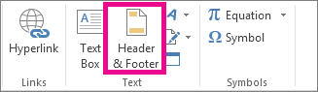

Excel displays the worksheet in **Page Layout** view.

1. To add or edit a header or footer, click the left, center, or right header or footer text box at the top or the bottom of the worksheet page (under **Header**, or above **Footer**).
2. Type the new header or footer text.